

**Helpful resources you can use at home**

**Reception SPRING 1 curriculum Newsletter**

**White Rose Maths**

<https://whiterosemaths.com/>

At Ben Jonson we follow the schemes of work created by White Rose Maths.



**Foundation Years**  
 <https://foundationyears.org.uk/>

Resources and useful information all about the early years.

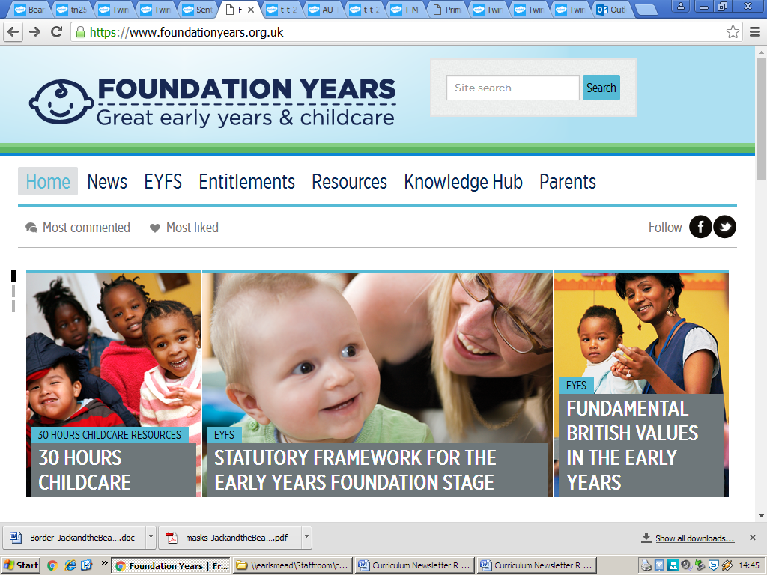

**Nrich Maths**   
 [www.nrich.maths.org/early-years](http://www.nrich.maths.org/early-years)  
 More maths resources and activities.

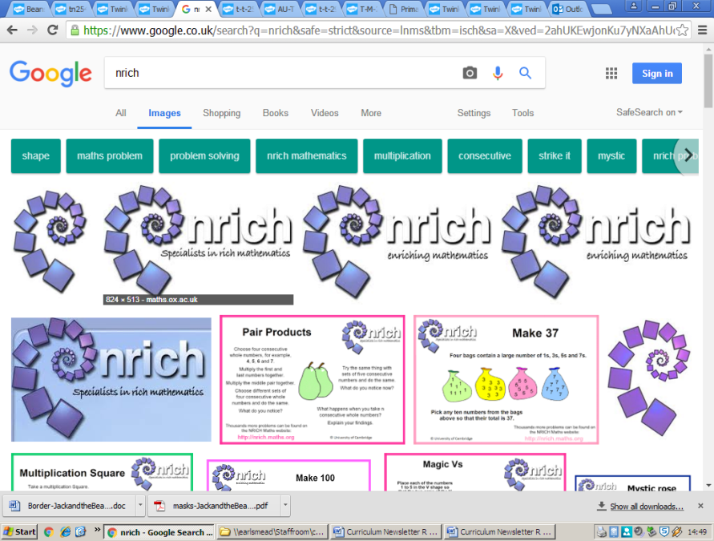

**Oxford Owl**  
<https://home.oxfordowl.co.uk/>  
Useful resource for understanding phonics, an e-book library and also some maths games and activities.

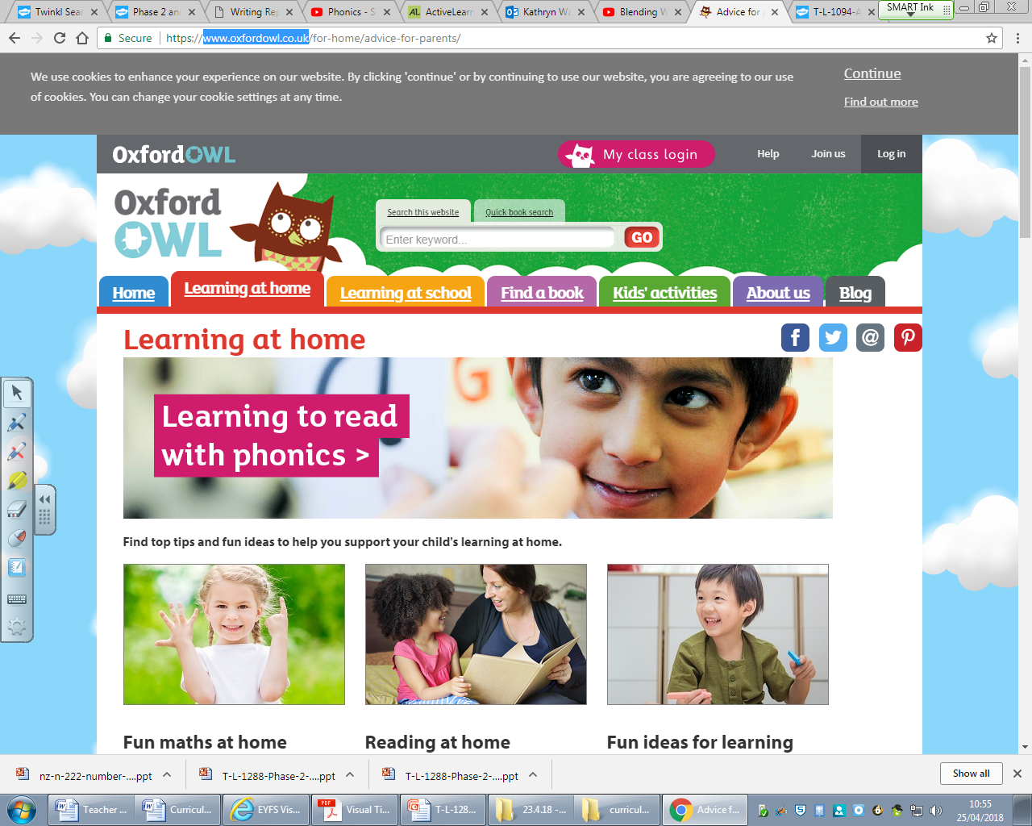

**10 minute shake up games**

<https://www.nhs.uk/healthier-families/activities/10-minute-shake-up/>

Get the kids moving with these fun games inspired by some of their favourite Disney characters. These boredom-busting activities will help them reach the 60 active minutes they need every day.

**Cbeebies**  
[www.bbc.co.uk/cbeebies](http://www.bbc.co.uk/cbeebies)   
A selection of fun games and videos linked to children’s favourite stories and television programmes.

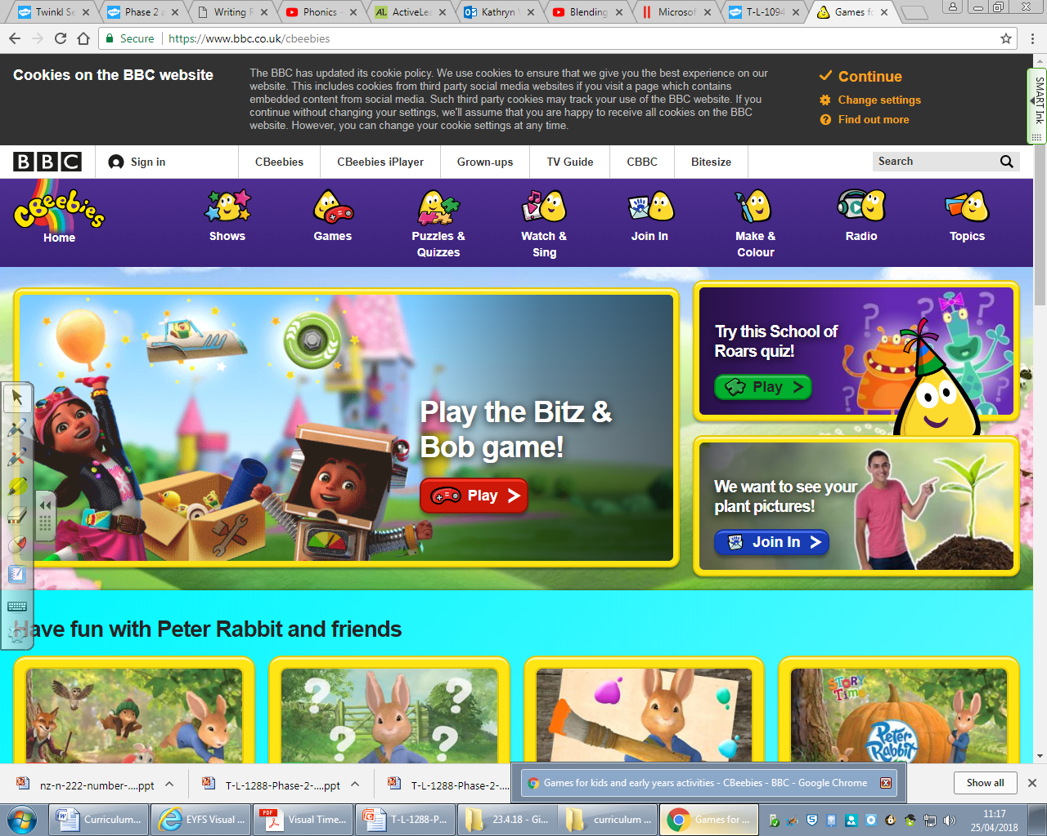



**Literacy**

READING:

* We will start guided reading in a small group once a week. They will be learning to read simple phrases and sentences. Children will bring a book home based on what they are learning in RWI.
* They will continue to learn to read the high frequency words.

PHONICS:

* Ensuring that we know all of the single letter sounds. Learning the ‘special friends’ diagraphs (sh, th, ch, qu, ng, nk).
* Blending the sounds into words so children can read short words that are made up of known letter-sound correspondences, and apply this in our writing.

WRITING:

* Spell words by identifying the sounds then writing these words, as well as learning to write the high frequency words.
* Continue to follow the model for writing: Think it, say it x3, write it, re-read it, and check if it makes sense.

**Books we are reading this half term:**

* Farmer Duck
* Rumble in the Jungle
* The Rainbow Fish
* How do dinosaurs….series of books

**Expressive Art and Design**

* Using our imagination to develop storylines in our pretend play.
* Create collaboratively, sharing ideas, resources and skills.
* Learning through songs, rhymes and music.
* Drawing and painting carefully, including details and accurate representations.
* Plan, do, review to construct with purpose and think of ways to improve our creations.

**Personal, social and emotional development**

* Turn taking/ sharing and responding to the ideas of others.
* Talking about what we are good at and what we need help with.
* Continue to developing our independence.
* Find solutions to conflicts and rivalries by talking to others.
* Talk about and express our feelings.
* Make healthy choices about food, drink and activities.

**Physical Development**

* Continue developing our fine and gross motor skills to help us to hold a pencil, scissors and other tools.
* Jumping and landing safely, moving confidently in a range of ways.
* Become more independent at getting dressed and undressed, taking off their own jumpers and learning to zip up their coats.

**Reception**

**Animals and dinosaurs**

**Mathematics**

* Introduce zero
* Find 0-5
* Subitise and represent 0-5
* 1 more and 1 less
* Composition of numbers up to 8
* Compare mass and capacity
* Find and represent 6,7, and 8
* Make pairs- odd and even
* Doubles to 8- find and make
* Combining 2 groups
* Conceptual subitising